Expression of Interest Form

We are looking for short proposals outlining how you would use the Connecting health communities support offer to reduce health inequalities during 2021-2022.
Area:
Lead Contact
Name: | Role:
Email: | Phone:
Please could you name two or more senior leaders working in the local area who are supportive and willing to be actively involved in this programme (One would need to be a voluntary organisation supporting communities that face health inequalities and others could be from the ICS, including the CCG, Health and Wellbeing Board, and PCN)
Organisation:
Name: | Role:
Email: | Phone:
Organisation:
Name: | Role:
Email: | Phone:
We haven’t set a word limit for the questions below, but we’re expecting short answers of a few paragraphs.
- Briefly describe your ideas for how collaborative working can contribute to tackling health inequalities in your area.

- What are your initial thoughts about how people directly affected by health inequalities will be involved in this work?

- Briefly outline any relevant work that is already underway.

>> Please return this form to Sonakshi@ivar.org.uk by 5pm 25th June 2021. <<

Further information

Find out more about this opportunity here, or book a time slot to speak to a member of the team please email or call Sonakshi Anand at Institute of Voluntary Action Research (IVAR): Sonakshi@ivar.org.uk // 07464548859

Meet the team
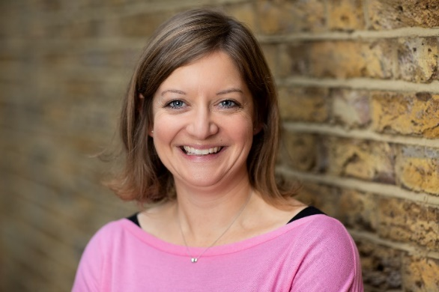
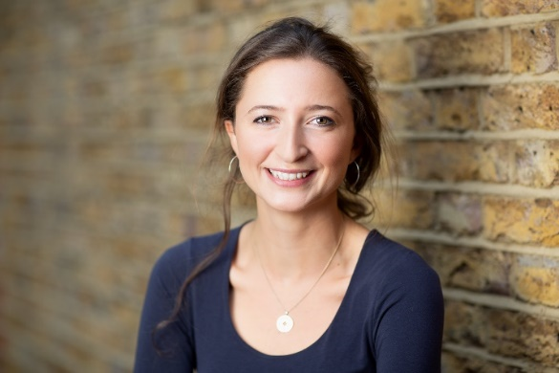
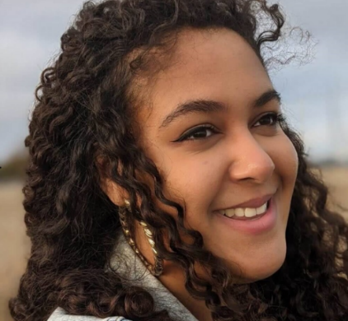
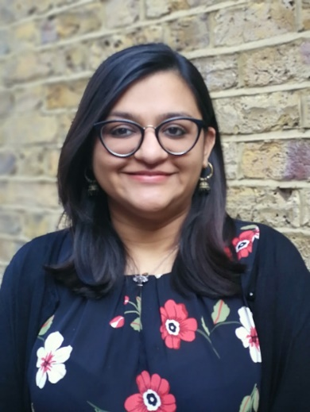
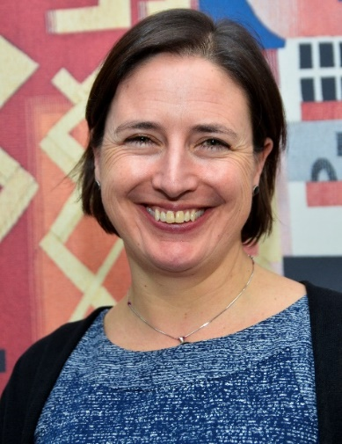
Delivery team:
Sonakshi Anand
Programme Manager and Facilitator
Charlotte Pace
Facilitator
Helen Garforth
Facilitator
Katie Turner
Facilitator
Annie Caffyn
Co-facilitator & Researcher
Keeva Rooney
Co-facilitator & Researcher
Comms team:
Emily Dyson, Communications lead
Natalie Corlett, Communication officer
Vanessa Norris, Events coordinator

Advisory group:

Alex Hayes, Head of Funding (strategic programmes), National Lottery Community Fund

Annthadine Ntorinkansah, Senior Projects Coordinator, Voice4Change England

Ben Cairns, Director, Institute for Voluntary Action Research (IVAR)

Carrie McKenzie, Voluntary Partnerships Senior Manager, Voluntary Partnerships Team, Voluntary Partnerships Team, NHS England and NHS Improvement

Dr. Esther Oenga, Trustee member, Utulivu

Julie Clayton, Head of Communications and Engagement, NHS North Cumbria CCG and North Cumbria ICP

Peta Wilkinson, Chief Executive, Willen Hospice, Milton Keynes

Tracy Hopkins, Chief Executive Officer, Citizens Advice Blackpool

Principles of our approach
Seven principles underpin and shape our approach to supporting cross-sector partnerships to engage meaningfully and productively in improving local health and care systems.

