Connecting health communities, 2021-2022 – expression of interest

We are inviting expressions of interest for an 18-month facilitation support package –

to enable cross-sector partnerships to address health inequalities in Integrated Care Systems and Primary Care Networks. Details of how to apply can be found on page 2.

At the Institute for Voluntary Action Research (IVAR), we’ve been supporting cross-sector partnership working that delivers improved health outcomes for 15 years – most recently through Building Health Partnerships and Transforming Healthcare Together.

Through our new initiative, Connecting health communities, we will support eight partnerships over 18 months – in two waves. We would like to hear from cross-sector groups who are interested in facilitation support, to kick-start or sustain partnerships that deliver improved health outcomes for vulnerable groups, reducing the health inequalities they face.

We will initially select four areas to work with from July 2021 to December 2022. We would like to work with groups across England and at different stages of their partnership journeys. If we have worked in your area recently, please contact us before submitting an expression of interest by emailing sonakshi@ivar.org.uk.

We may be able to provide modest financial support to enable the participation of communities who experience health inequalities and for venue hire (although we expect this work to begin remotely via Zoom or Microsoft Teams).

We will also provide six one-off facilitated workshops each year of this three-year initiative, so if you are unsuccessful for the full 18-months of support we may contact you about this lighter-touch offer.

Connecting health communities is funded by the National Lottery Community Fund; and supported by an advisory group with representation from NHS England and Improvement, people with experience of cross-sector partnership working and people who support those experiencing health inequalities.

More information on commitments, activities and timeline is contained in Appendix 1 (page 3).

Our aspirations for this work
We have four high-level aspirations:
- People with experience of health inequality are meaningfully involved in the co-design and co-production of health and care in and for their communities.
- People and communities with experience of health inequality are trusted partners in decision-making about their health and wellbeing.
- Activities that help people stay well and healthy happen in spaces and ways that communities feel ownership of.
- Voluntary, community and social enterprise organisations are recognised, valued and resourced to connect people in communities with each other for their health and wellbeing.

Context: Why health inequalities?
Covid-19 has further exposed the health inequalities that exist across the UK, with research showing that groups experiencing racial injustice, those living in deprived areas, and people working in lower-paid professions are more vulnerable.

We understand health inequalities to be driven by various determinants of health such as housing, income, employment, education, social isolation or disability – all of which affect people’s access to good healthcare. In Connecting health communities, groups will determine what ‘health inequalities’ means for them, and how they intend to tackle them through cross-sector partnership working.

While Covid-19 has exposed health inequalities, we have also seen accelerated progress in partnership working in several local areas responding to the pandemic. We have heard how previous barriers – such as information governance, organisational boundaries and agendas, and lack of trust – have been removed, or set aside, in order to respond swiftly to a ‘tsunami of need’. Partnerships have shared how they have reached their most isolated and vulnerable community members; protected against overwhelming demand on statutory health services; and improved referral pathways by recognising and playing to the strengths of the different partners.

Making an application
To make an application, please fill out the simple, one-page Expression of Interest (EOI) form (which can be completed online, or in Appendix B on page 6) which requires you to:

- Demonstrate senior representation with named leads from health, statutory and voluntary organisations.
- Demonstrate how people directly affected by health inequalities will be involved in this work.
- Identify a particular health inequality that, with focused support, a cross-sector partnership could help to tackle – including any relevant work already underway.

Overall, we’re looking for a few paragraphs setting out your ideas.

The deadline for sharing the expressions of interest is 5pm on 25th June 2021. We would like to have a conversation after you submit your EOI to better understand what support would work best for the particulate health inequality your partnership is trying to work towards, and we will book in these calls in the week commencing 28th June 2021. Successful applicants will be informed during the week commencing 5th July 2021.

Through this work, we aim to reach communities and remove traditional obstacles to participation. Hence, if the EOI form is a barrier in any way, please do get in touch with us by emailing or calling Sonakshi Anand at the Institute for Voluntary Action Research (IVAR): Sonakshi@ivar.org.uk // 07464548859.

Appendix 1: Further information about Connecting health communities
We will work in areas where communities face health inequalities, to design and deliver positive action through a cross-sector partnership of voluntary and local healthcare organisations.

- In each area, we will start by asking our cross-sector group two key questions: ‘what do health inequalities look like locally?’ and ‘how can we tackle them together?’.
- Subsequent work is likely to focus on strengthening the foundations of partnership working and supporting local leaders to deliver improved health outcomes for vulnerable groups by:
  - Building the evidence base and case for change
  - Adapting systems and structures
  - Initiating and introducing new services
  - Identifying and achieving opportunities for a more sustainable and fairer model of healthcare
- We will support you to develop opportunities for more effective engagement of community groups and voluntary organisations in the design, commissioning and delivery of health and social care services.

You may have worked together before; or started working together but not yet have fully formed plans – the most important thing is to be a cross-sector group with an idea of what you would like to change.

You can read examples of work previous partnerships have undertaken here, although please note that this work did not focus on health inequalities.

The offer:
- Bespoke, facilitated support for a period of 18 months
- Access to a dedicated team who will support the scoping phase and development of a project Steering Group
- Facilitation of cross-sector and multi-stakeholder events to set shared priorities and agree joint action
- Access to three peer learning events and a bank of resources from previous cross-sector partnerships

Connecting health communities involves activities for a ‘steering group’ and a wider ‘partnership group’ as described below:

- Steering group: Key stakeholders from across the local area, representing the cross-sector group, who (with the support of IVAR facilitators) will drive and support the work outside the facilitated sessions. Usually a group of eight or more people, most often those named on the application. They will be provided with support to lead this programme in their area. It is important to have a community leader on this group.
- Full partnership/Co-designing days: Involving all interested parties within the local area. The steering group will seek representation from across sectors as well as community group voices to shape and take forward agreed activity. These sessions usually involve around 30-60 people. Workshops can take place either online on the most accessible tool (e.g. Zoom/Microsoft teams) or face-to-face.
- Peer Support Network: A regular space for the participants and others to share learning, challenges and support each other in the pursuit of cross-sector collaboration in health and care, providing peer support and using examples from their own work in the areas to inspire and motivate other areas. Up to three meetings will take place over the course of the 18-months, and this may include a wider audience.
- Anchor organisation: An organisation based locally that will support involvement of communities experiencing health inequalities. They will also be responsible for cascading information following each co-design/partnership session; and coordinate with other communications leads in the local area to disseminate national learning through their networks. There is a small budget to support anchor community organisations working predominantly at a local level, if money is a barrier to their involvement. These will be identified with the facilitator and steering group, when the local area conversations begin.

The table below provides an outline of activities. These are flexible and be developed based discussions with leaders from the local healthcare systems, local authorities, voluntary organisations and local communities involved in shaping the programme. The core aspect of the programme must involve four co-design days with participation from the wider groups and at least 6 steering group meetings.

The initial meetings will happen online and may move to face-to-face, which will be reviewed as the pandemic restrictions change.

Date | Activity | Purpose
July- August 2021 | Scoping Phase and instituting the steering group | Introduction to the programme, exploration of local contexts and establishment of the steering group
Early September 2021 | First Steering Group meeting | Providing support to the steering group to design a process to involve the right people across the system, to provide tangible outcomes.
October 2021 | Second Steering Group meeting | Getting an action plan ready for Cross sector partnership development, setting shared priorities and agreeing an action plan.
October – November 2021 | Partnership meeting one | Cross sector partnership development, setting shared priorities and agreeing an action plan.
December 2021 | Steering group meeting | Develop work and take forward actions and ideas from the partnership meeting. Plan for cascading messages and influencing system leaders.
Jan – Feb 2022 | Partnership meeting two | Action planning & implementation with full group

Minimum commitment for an area’s involvement with Connecting health communities
- Buy-in and support from the local healthcare system and attendance by senior leadership from ICS, CCG, Local Authority/Public Health, Community representative and Voluntary organisation from across the local area. Leads from each sector must be available for set-up discussions and a first meeting in July-August.
- Commitment to form a cross-sector steering group of senior health and care stakeholders as a steering group to lead the programme work (if none already exists)
- Attend up to four half-day co-designing days facilitated by IVAR (with contributions from experts and input from the core team), with a wider group of 30-60 participants (including community and groups), commencing in October following set-up discussions.
- Attend at least six steering group meetings (face-to-face or virtual), plus some out-of-meeting input.
- Commit a named person from one of the lead organisations to support the administration locally. This will involve coordinating dates/diaries, booking venues, contributing to note-taking, handling communications with the wider group between sessions.
- A named person from one of the lead/anchor organisations to support communications locally.
- Commitment to supporting us to share learning and models with other local areas through a peer support network.
- Commitment from local partners to share data in line with a partnership agreement

All partners will be expected to commit senior staff time to leading this work.

Appendix 2 - Expression of Interest Form

We are looking for short proposals outlining how you would use the Connecting health communities support offer to reduce health inequalities during 2021-2022.
Area:
Lead Contact
Name: | Role:
Email: | Phone:
Please could you name two or more senior leaders working in the local area who are supportive and willing to be actively involved in this programme (One would need to be a voluntary organisation supporting communities that face health inequalities and others could be from the ICS, including the CCG, Health and Wellbeing Board, and PCN)
Organisation:
Name: | Role:
Email: | Phone:
Organisation:
Name: | Role:
Email: | Phone:
We haven’t set a word limit for the questions below, but we’re expecting short answers of a few paragraphs.
- Briefly describe your ideas for how collaborative working can contribute to tackling health inequalities in your area.

- What are your initial thoughts about how people directly affected by health inequalities will be involved in this work?

- Briefly outline any relevant work that is already underway.

>> Please return this form to Sonakshi@ivar.org.uk by 5pm 25th June 2021. <<

Further information

To find out more about this opportunity or book a time slot to speak to a member of the team please email or call Sonakshi Anand at Institute of Voluntary Action Research (IVAR): Sonakshi@ivar.org.uk // 07464548859

Meet the team
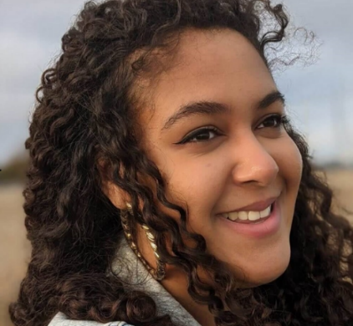
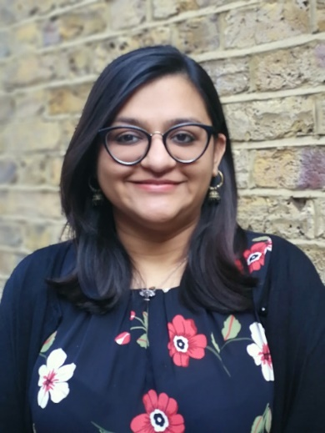
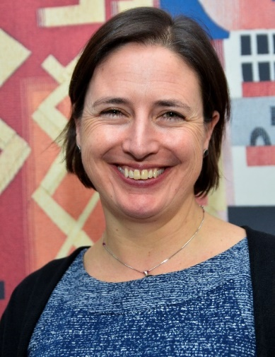
Delivery team:
Sonakshi Anand
Programme Manager and Facilitator
Charlotte Pace
Facilitator
Helen Garforth
Facilitator
Katie Turner
Facilitator
Annie Caffyn
Co-facilitator & Researcher
Keeva Rooney
Co-facilitator & Researcher
Comms team:
Emily Dyson, Communications lead
Natalie Corlett, Communication officer
Vanessa Norris, Events coordinator

Advisory group:

Alex Hayes, Head of Funding (strategic programmes), National Lottery Community Fund

Annthadine Ntorinkansah, Senior Projects Coordinator, Voice4Change England

Ben Cairns, Director, Institute for Voluntary Action Research (IVAR)

Carrie McKenzie, Voluntary Partnerships Senior Manager, Voluntary Partnerships Team, Voluntary Partnerships Team, NHS England and NHS Improvement

Dr. Esther Oenga, Trustee member, Utulivu

Julie Clayton, Head of Communications and Engagement, NHS North Cumbria CCG and North Cumbria ICP

Peta Wilkinson, Chief Executive, Willen Hospice, Milton Keynes

Tracy Hopkins, Chief Executive Officer, Citizens Advice Blackpool

Principles of our approach
Seven principles underpin and shape our approach to supporting cross-sector partnerships to engage meaningfully and productively in improving local health and care systems.

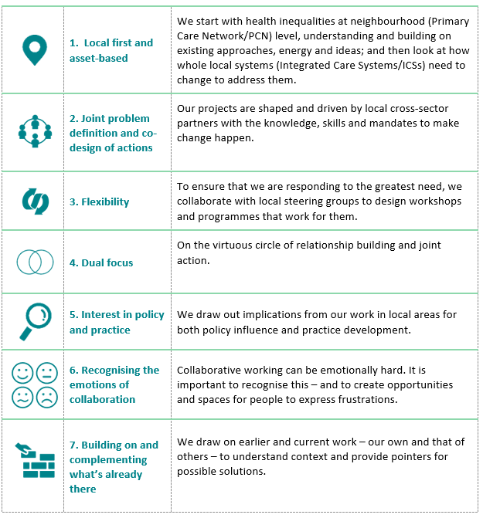

Bedfordshire, Luton and Milton Keynes; Dorset; Lancashire and South Cumbria; Nottingham and Nottinghamshire; North Cumbria; Surrey Heartlands; West Yorkshire and Harrogate.
Public Health England report, Disparities in the risk and outcomes of Covid-19
Briefing from PDN: Barriers are coming down
We’re better together: How the health sector has worked in partnership during the Covid-19 crisis

