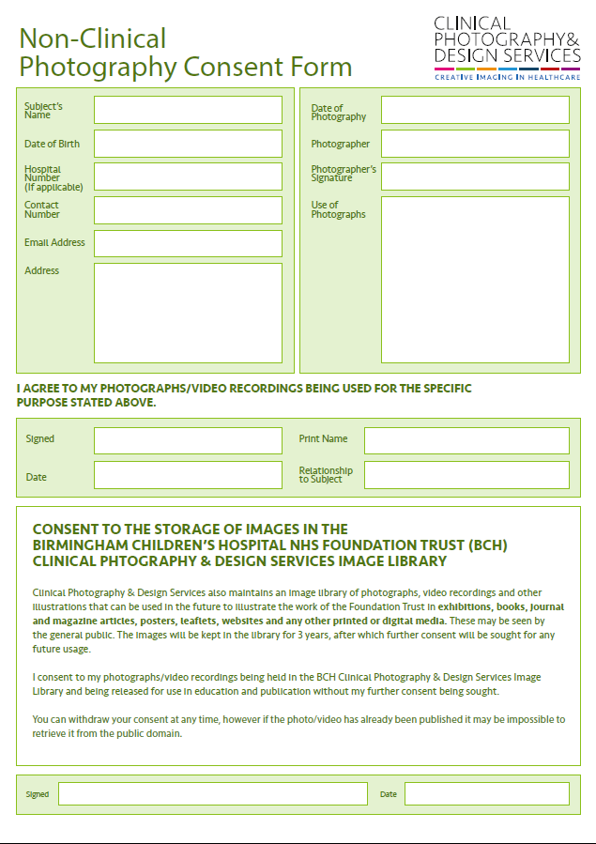

Photos / video will be used for up to 3 years to promote and celebrate the Junior Volunteer programme specifically, and volunteering programme at Birmingham Women’s and Children’s NHS Foundation Trust in general, in print, electronic documents and online (including social media). Photos may also be used as part of moving image presentations / videos.

N/A