Building Health Partnerships in Lancashire and South Cumbria: Thursday 22nd November 2018

Partnership Meeting 1: Summary of Discussion
What does Partnership mean to you in Lancashire and South Cumbria?
- Partnership should be aspirational, adventurous and brave.
- Hopeful for improvement and doing things differently.
- Partnership requires patience to reach a mutual and common understanding.
- Sometimes partnership feels like a game of chess… some people do not want to play and no one knows what winning means.
- Partnership can be challenging with multiple barriers.
- Insightful – there is good practice in Lancashire that can be replicated elsewhere. Lancashire has a very proactive community.
- Individuals with different experiences and from different backgrounds joining with a shared purpose and goal.

Key Messages from the Meeting:
- Current situation in Lancashire and South Cumbria:
Appetite for doing things differently and for using the BHP programme to put learning into practice. Profound changes could be reached within this community of VCFS and statutory partners.
A desire for clarification around the purpose of the partnership and the roles within it – there are increasing conversations about having greater impact but this is still at the early stages.
Services are fragile, fragmentary and suspicious about each other, and smaller voluntary organisations have previously been underrepresented in discussions.
- The current key challenge: Power and Equity
Power is locked into authority – it is difficult to shift this power from institutions towards the community unless the whole community is involved.
Desire for equality in the partnership with clear expectations and a move towards practical action.
Difficult to capture what ‘community involvement’ is. There is a demand to support people in understanding how to build on the current system.
- ICS Partnership landscape: how is the VCFS engaging with the ICS?
Leaders from the ICS are including the VCFS in the partnership and are aiming to avoid tokenistic representation. The 5 different ICP areas are at a range of different levels and governance. Evolving ICP-based leadership structures which seem to be organic and with a strong level of support. They are trying to achieve vertical and horizontal integration so they are inclusive in their approach. Conversations are occurring – change is needed in both the NHS and in the VCFS but there needs to be clarification about:
- What is a whole systems approach?
- How to frame the partnership (i.e. are we all saying the same thing?) How to move away from a medical model framing of doing things to communities, and instead, with communities. Create a coherent model across the community.
- How to challenge the cultural dynamic between leadership and the operational level.

- Possible ways to move forward/ possible outcomes of the programme:
- Address the inequalities in our communities and think more broadly and longer-term about capacity building.
- Build on existing structures, rather than creating a new one.
- Strengthening the relationship before changing the culture.
- Develop a new culture of working together and make this visible.
- Consistency across the ICP’s to avoid problems of asymmetries. It needs to be intrinsic to the whole system approach and have wide relevance.
- Learn from the sector and other ICP’s to ensure that partnership is genuine and that everyone is represented.
- Include beneficiaries and voluntary sector when designing this partnership so that change can occur at scale.
- Voluntary sector is keen to contribute and is an innovative sector to test new approaches.
- Infrastructure organisations are under pressure to diversify – there needs to be investment in development work to grow capacity and to strengthen the ‘community connector level’.
- Provide services into preventative work through an efficient and flexible partnership.
- Provide evidence and an example of what the VCFS can deliver for healthy neighbourhoods – demonstrate this value across the system to build confidence in VCFS and statutory organisations. This will share the message that there are alternative services outside the NHS.

- Adapted Question Focus
Throughout the course of the meeting, the focus question that was adapted was…
How do we use the BHP programme to get a system approach to VCFS engagement across the ICS?
Updated question - How do we use the Building health Partnerships programme to develop a new culture of working together between the VCFS and the statutory sector in neighbourhoods, ICPs and across the ICS – because we want to harness the leadership, power and capacity of our communities to improve their own health and wellbeing.

Summary of the flipchart exercise around possible priorities
Priority 1: VCFS as a primary partner
Immediate actions to get there:  - Prove the value of the existing impact that the VCFS in Chorley is having. | Future steps:  - Work towards an integrated system.  - Shift towards prevention work and improving health outcomes which saves money.  - There is no new money – recycle money into VCFS once the value is proven.

Priority 2: Shift the current working culture and strengthen relationships
Immediate actions to get there:  - Engagement with neighbourhood, ICP and ICS  - Develop a common language  - Identify community needs  - Identify and engage the less heard grass roots organisations  - Communicate successes!  - Shape case studies. | Future steps:  - Peer support/ mentorship – share learning between healthcare practitioners and VCSE  - Explore public sector workforce challenges innovatively – could the VCSE address some of these challenges?  - Explore redistribution of resource – ROI vs SROI commissioning/ decommissioning challenges.

Priority 3: Collaboration – Build consistent “models” of engagement at ICP level
Immediate actions to get there:  - Choose 3 neighbourhoods  - Choose a theme  - Try a different way of engaging  Demonstrate the impact each approach can have when involving community connectors, CVS, and council support. | Future steps (outcomes):  - Trial something in a neighbourhood at 3 different levels (ICS, ICP, and Neighbourhood)  - Ask the neighbourhood to choose a theme  - Roll out recommendations  - Test effectiveness and unintended consequences  - Adequately support those organisations to trial different models.  - Work towards consistent principles of engagement

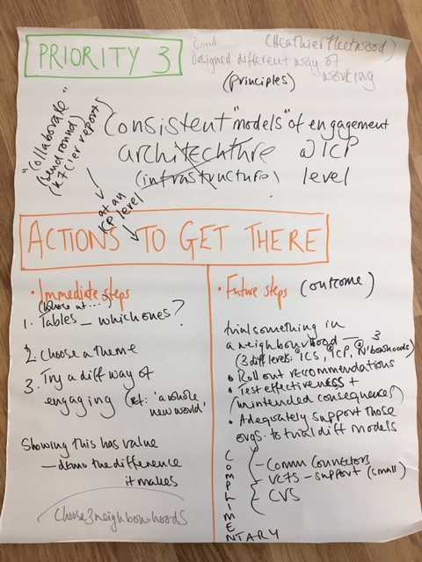
Appendix - Flipcharts from table discussions about the 3 possible priorities:
